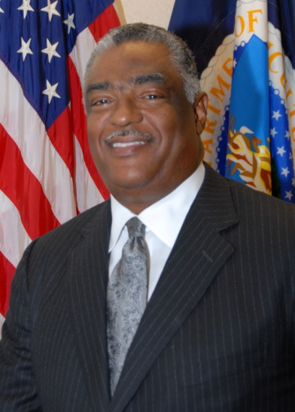**Donald E. Arnette, Regional Administrator**

**USDA Food and Nutrition Service, Southeast Regional Office**

Donald Arnette is a senior career official with 40 years of service at various levels within the U.S. Department of Agriculture. Currently, as the Regional Administrator for the Southeast, he provides executive direction and leadership in executing the FNS programs to ensure that directives of the Secretary and the agenda of the Administration are accomplished. Mr. Arnette orchestrates the execution of all 15 federal nutrition assistance programs that provide annual benefits in excess of $21 billion through cooperating state agencies in Alabama, Florida, Georgia, Kentucky, Mississippi, North Carolina, South Carolina, and Tennessee. FNS programs reach 1 in 4 Americans over the course of a year.

Prior to his appointment as Regional Administrator, Mr. Arnette was the Deputy Administrator for Management, Food and Nutrition Service, in Alexandria, Virginia. In that role he oversaw the operational implementation and activities of the agency’s Human Resources program, Civil Rights and EEO program, Administrative Services Division, Information Technology Division and Homeland Security requirements.

Previously, Don was the Deputy Regional Administrator for the FNS Southwest Region in Dallas, Texas, where he built coalitions and partnerships that proved invaluable in expanding access to public programs in Arkansas, Louisiana, New Mexico, Oklahoma and Texas. He was personally awarded the USDA Award for Superior Service by the Secretary of Agriculture for his success in improving State and Federal business practices and in achieving cost saving exceeding $60 million in the Food Stamp Program.

In addition, Don is also the recipient of the Hammer Award for Reinventing a Government that Costs Less and Works Better, USDA Secretary’s Honor Award, FNS Administrator’s Award and numerous other awards from state governments and Historically Black Colleges and Universities.